Bahria University,

Karachi Campus

LAB EXPERIMENT NO.

07

LIST OF TASKS

|  |  |
| --- | --- |
| TASK NO | OBJECTIVE |
| **01** | Design and implement a web service that provides currency conversion functionality. The web service should accept requests to convert an amount from one currency to another and return the converted amount. |
| **02** | Design and implement a web service that provides scientific calculator functionality over the internet. The web service should allow users to perform various mathematical operations, including basic arithmetic, trigonometric functions, logarithms, and more. |
|  |  |
|  |  |
|  |  |
|  |  |
|  |  |
|  |  |

Submitted On:

21-03-2024

(Date: DD/MM/YYYY)

**Task No. 01**: Design and implement a web service that provides currency conversion functionality. The web service should accept requests to convert an amount from one currency to another and return the converted amount.

**Solution:**

using System;

using System.Collections.Generic;

using System.Linq;

using System.Web;

using System.Web.Services;

namespace WebApplication1

{

/// <summary>

/// Summary description for CurrencyConvertor

/// </summary>

[WebService(Namespace = "http://tempuri.org/")]

[WebServiceBinding(ConformsTo = WsiProfiles.BasicProfile1_1)]

[System.ComponentModel.ToolboxItem(false)]

// To allow this Web Service to be called from script, using ASP.NET AJAX, uncomment the following line.

// [System.Web.Script.Services.ScriptService]

public class CurrencyConvertor : System.Web.Services.WebService

{

[WebMethod]

public int CurrencyConversion(int EnterAmount,int ConversionRate=290,string CurrencyName="USD")

{

return EnterAmount * ConversionRate;

}

}

}

**Output:**

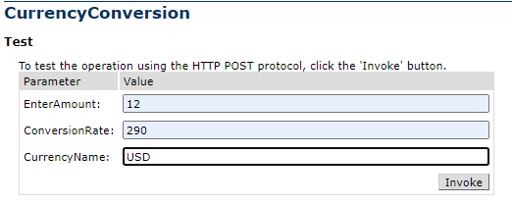

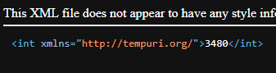

**Task No. 02**: Design and implement a web service that provides scientific calculator functionality over the internet. The web service should allow users to perform various mathematical operations, including basic arithmetic, trigonometric functions, logarithms, and more.

**Solution:**

using System;

using System.Collections.Generic;

using System.Linq;

using System.Web;

using System.Web.Services;

namespace WebApplication2

{

/// <summary>

/// Summary description for ScientificCalculator

/// </summary>

[WebService(Namespace = "http://tempuri.org/")]

[WebServiceBinding(ConformsTo = WsiProfiles.BasicProfile1_1)]

[System.ComponentModel.ToolboxItem(false)]

// To allow this Web Service to be called from script, using ASP.NET AJAX, uncomment the following line.

// [System.Web.Script.Services.ScriptService]

public class ScientificCalculator : System.Web.Services.WebService

{

[WebMethod]

public int addition(int EnterNumber1, int EnterNumber2)

{

return EnterNumber1 + EnterNumber2;

}

[WebMethod]

public int Subtraction(int EnterNumber1, int EnterNumber2)

{

return EnterNumber1 - EnterNumber2;

}

[WebMethod]

public int Multiplication(int EnterNumber1, int EnterNumber2)

{

return EnterNumber1 * EnterNumber2;

}

[WebMethod]

public int Division(int EnterNumber1, int EnterNumber2)

{

return EnterNumber1 / EnterNumber2;

}

[WebMethod]

public int Cosine(int EnterNumber1)

{

return (int) Math.Cos(EnterNumber1);

}

[WebMethod]

public int Sine(int EnterNumber1)

{

return (int)Math.Sin(EnterNumber1);

}

[WebMethod]

public int Tangent(int EnterNumber1)

{

return (int)Math.Tan(EnterNumber1);

}

[WebMethod]

public int CosineInverse(int EnterNumber1)

{

return (int)Math.Cosh(EnterNumber1);

}

[WebMethod]

public int SineInverse(int EnterNumber1)

{

return (int)Math.Sinh(EnterNumber1);

}

[WebMethod]

public int TangentInverse(int EnterNumber1)

{

return (int)Math.Tanh(EnterNumber1);

}

[WebMethod]

public int Log(int EnterNumber1)

{

return (int)Math.Log(EnterNumber1);

}

[WebMethod]

public int LogBase10(int EnterNumber1)

{

return (int)Math.Log10(EnterNumber1);

}

}

}

**Output:**

